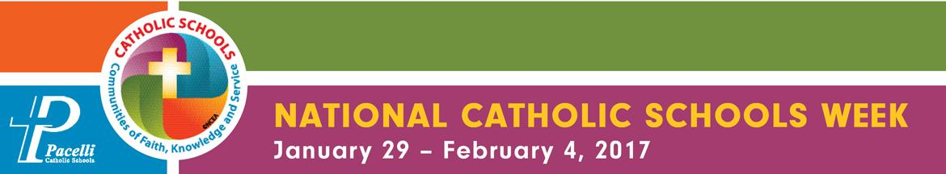

PACELLI CATHOLIC HIGH SCHOOL
Dress Up Days & Activities

Monday, January 30: Pacelli Pride Day

Tuesday, January 31: Pajama Day

Wednesday, February 1: Super Sports Fan Day
- 1-1:45PM: Elementary Run Out to St. Stan’s & St. Brons - working & playing with elementary students

Thursday, February 2: Patriotic Day

Friday, February 3: Dress Up for Jesus Day
- 9:02AM: Mass for Grades 5-12 at Pacelli High School in the FACC
- 9:52AM: Community Meeting for Grades 5-12 at Pacelli High School in the FACC
- 10:12AM: 8th Grade Tour of Pacelli High School & 2017-2018 Course Signup

